Feel The Frame Website Content

# Feel The Frame Colours:

Purple: 6320EE

White: FFFFF

Midnight: 211A1D

# Navigation Menu:



I want the nav menu to look something like above with the glass morphism aesthetic. I want this glass, light reflective look to be a style applied to the borders of boxes throughout the website. That doesn’t mean I want all boxes to be transparent, but if their edges could give the illusion that “light” is reflecting off of them, that would look sleek and amazing.

This Nav Menu should follow the user as they scroll down but should not occupy too much of their screen. It should always be present but not invasive in any way.

# 

# Website References:

<https://videohut.framer.website/> I like how the Nav Menu follows you down the screen as well as the glass morphism. I also love the footer. I also like the way the “projects” page is organized

<https://animotion-164e28.webflow.io/> I like how icons animate when you scroll down to the services section

<https://www.uxcreatives.com/web-design> I love the way the websites at the bottom beneath the hero text animate onto screen like a pack of cards. The motion feels very fluid

<https://www.crojungle.com/> I love how this website has subtle motions throughout it like how there is a light in the background that follows my mouse, and how when I hover over some panels, they move in a subtle way. It’s not too flashy but also not too simple and basic. I love the little text animations when you hover over “startups” and “ecommerces”. I also love how there are custom cursors that say “view” when you hover over a certain box. Very fluid, responsive, and always moving in some way. The box that says “we make brands 10x” I love how it moves in a 3D way. I also love how the nav menu and certain boxes throughout the page have a “light shining” effect. It looks very elegant and adds a lot of dimension. Overall an amazing website.

<https://drive.google.com/file/d/1lti-MyKprsGxpKscffEgnDb7fQhg93-s/view?usp=sharing>

I love the way this button animation looks

<https://www.noldio.com/> I love the way 3d Elements float around the hero text. However with my home page, I want the 3D icons to float from the background of my logo into the foreground surrounding my logo. Also, SUPER IMPORTANT, if you press play on the video of this website beneath the hero text, it has a custom video player UI. I want something similar but more rounded, sleek, and doesn’t have super sharp edges. This custom video player UI on this website looks more like vimeo, which I don’t like the UI of. But I just want to show you what I mean by custom video player UI

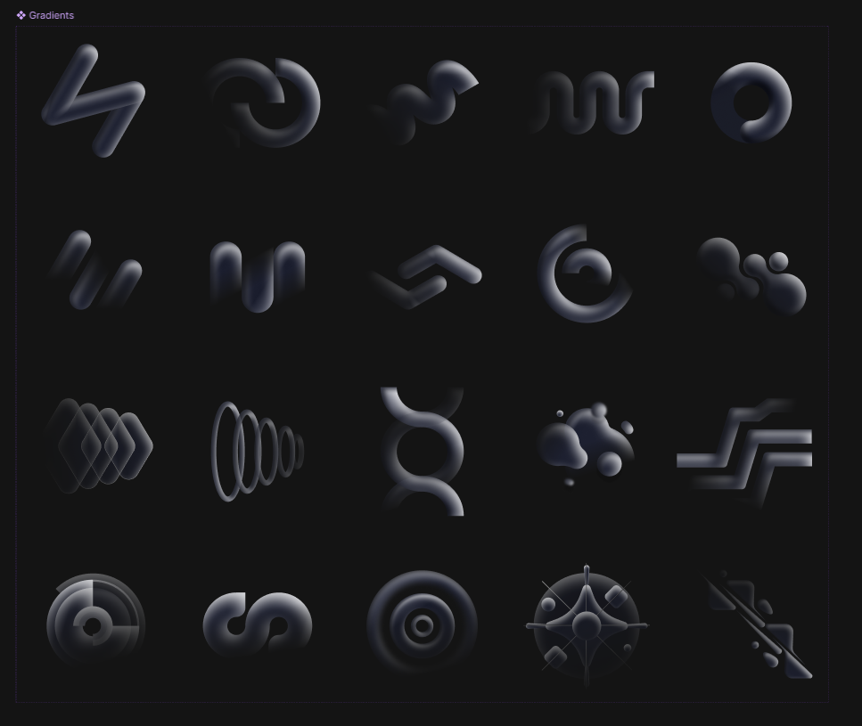

In the image above, I love these vector designs in figma. They are abstract, cinematic, sleek, and they look like light is shining off of them. If we could make something like this in the background of the webflow website that would be amazing. And since they are vectors, if we could make the individual layers move and animated separately from one another that would be amazing! I want something custom for the website similar to these. But if you can’t I can just provide the figma file I have on my end and you can use these.

# Footer:

A footer like this looks great. Feel free to take inspiration from it but don’t include the “newsletter” thing. I don’t have any specific ideas for the footer though so get creative if you’d like or keep it simple, I’m open to suggestions.

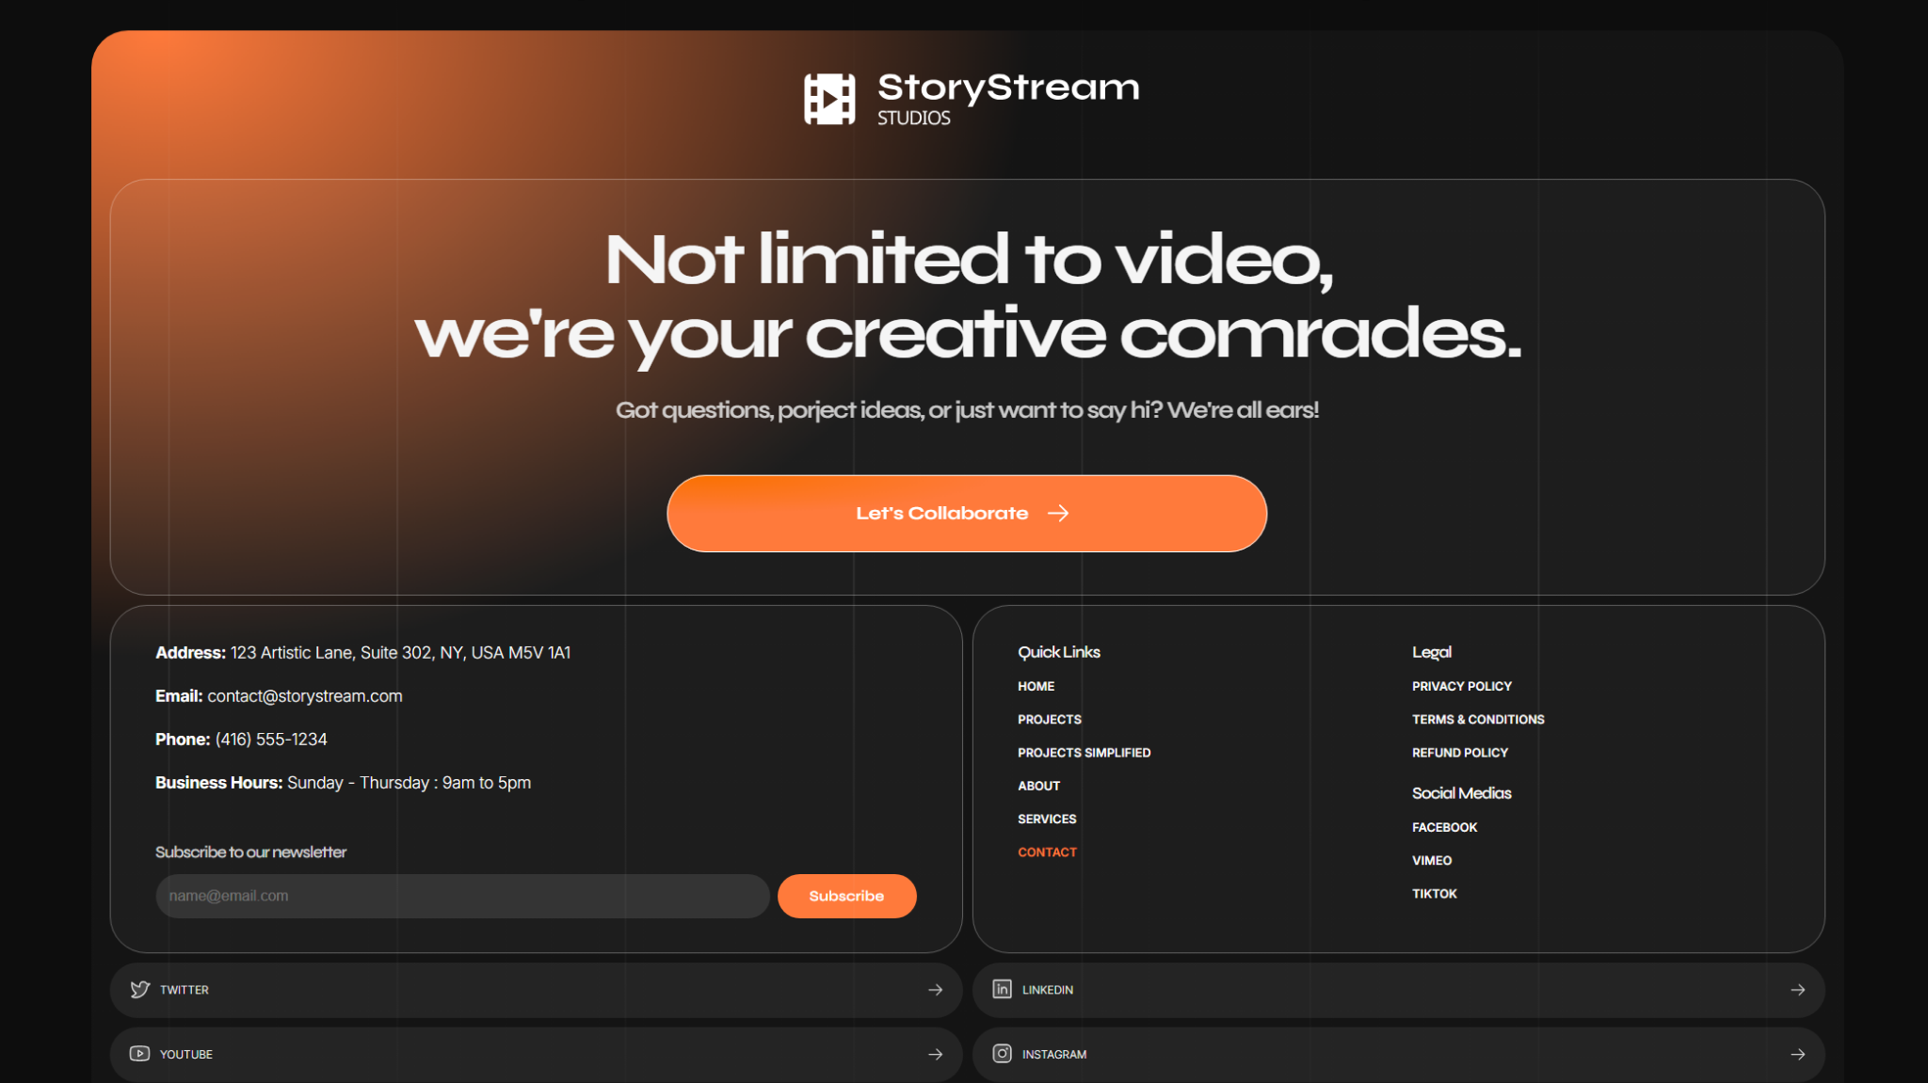

# Home Page:

**\*Everything will be listed in the order that it is supposed to be organized from top to bottom**

## Hero Section (top of Home page):

* Slogan: Optimize your marketing with video
  + Button: “View Showreel”
* Feel The Frame Logo to the left of Slogan

## How We Help:

* Our Story:
  + Founded by Hammam Alashi, he set out to provide a video production service that wasn’t only about hitting records, but about collaborating with clients on a deeper level to fully understand their brand and elevate their marketing with video.   
      
    Over time, we developed our central philosophy: Marketing is all about emotions. About making people feel you have what they need. And that’s why we have what you need.
* Our Mission:
  + Feel The Frame is a Commercial video production company that has always focused itself on one goal: To optimize your Marketing. We do this through a variety of services such as commercials, social media content, and corporate videos.  
      
    We are tailored to those who want to build something with their customers and clients. We provide every audio-visual tool you need to help build your brand. your message. your value.
* Our Promise:
  + We are about collaboration. We work with our clients as extensively as possible to offer a creative solution to help elevate your brand, leading you to gain more leads, conversions, Interactions, views, likes, subscribers, funding, and so on.

Our promise is this: No matter what idea or problem you come to us with, we will craft a solution that combines cinematic and auditory perfection to optimize your marketing.

## Showreel:

* Have a large thumbnail of the Feel The Frame Showreel, a play button on top of the thumbnail so people can press play.
  + Beneath the video, there should be a button that says “Wanna see more?” This button will lead the viewer to the “Portfolio” Page

## Services:

* **Commercials:** Trends fade and statistics change, but a great story creates a lasting connection. And your business’ story is the heart of our cinematic approach.
* **Corporate:** Corporate videos are a powerful tool for educating your audience on your services and foster a unique sense of loyalty with your target audience.
* **Social Media:** If you want to get ahead and leave a strong impression in today's crowded digital landscape, a professional video content strategy is essential.
* **3D Animation:** Some ideas are too big for the real world—that's where 3D animation comes in with a unique visual language that builds customer confidence and helps your business stand out.
* **VFX:** Bring your most imaginative ideas to life. Our VFX services seamlessly blend reality with 3D simulations to create visuals that are otherwise impossible.
* **Real Estate:** Sell your listings faster with our vibrant photography and immersive video tours, creating a powerful first impression that attracts more qualified buyers online.

## Our Process:

* **Pre Production:** This phase involves everything prior to filming. During Pre-production, we start off with listening before doing anything. Listening to your wants, needs, ideas, problems, and everything in between.
  + Concept Development: Our process begins with a collaborative session to define the core concept. Whether you have a clear vision or need creative direction, we work together to build a powerful strategy that perfectly aligns with your brand.
  + Scriptwriting: This is the most important step in pre-production. Developing the initial concept into a great narrative is what gives your video marketing strategy the opportunity to succeed.
  + Storyboarding & Animatics: Storyboards and animatics are the visual roadmap for your video. They allow us to establish the look, flow, and feel of the final piece before we ever even hit record.
  + Plan, Plan, Plan: Once all creative decisions have been finalized, it’s time to plan, plan, plan! That means we take care of hiring cast and crew, securing locations and studios, preparing equipment, producing shot lists, shot maps, call sheets, and creating a timeline that meets your deadlines.
* **Production:** This is where the most fun happens. This is where you press record and watch everything we’ve been planning for come to life:
  + Cinematography: We always ensure your video marketing strategy has great, evocative visuals that communicate confidence to your target market. We achieve this with our industry-standard cameras, lights, drones, gimbals, tripods, and more.
  + Sound Recording: Audio is half the battle! That means great visuals aren’t the only key to a strong video. Our recorders, lavaliers, and boom microphones ensure a level of audio-quality that can only be felt, not heard.
  + Great Talent: Whether it’s you or an actor in front of the camera, we are always giving constructive feedback that helps build a great on-screen image for your brand.
  + Green Screens: If the project requires VFX in some capacity, it’s important to set everything up properly during production, so that the post-production process goes smoothly and produces optimal results.
* **Post-Production:** This is where everything takes its final form and reaches completion. After days, weeks, or even months of hard word, we get to celebrate the fruits of our labour.
  + Editing: Clips are assembled together masterfully with meaningful cuts, transitions, and b-roll to communicate the story or message that was intended all the way back during the development of the concept.
  + Colour Grading: A great camera and masterful lighting setups are key to great visuals, but so is colour grading. We manipulate colours masterfully to align with the intended emotions, story, and style.
  + 3D Animation & CGI: If your video has any computer-generated elements, we utilize our top-of-the line 3D modelling and animation software, such as Cinema 4D and Houdini, to create beautiful visuals.
  + Sound Design & Music: We create rich soundscapes, record foley, and enhance/clean up any recorded audio to achieve a seamless auditory experience. We can also source music from extensive commercial libraries or create a completely original score in-house for your project.

# Our Work:

For the “Our Work” page, there isn’t any text you need to write really, nothing lengthy at least. Here is what I need:

* As soon as the page opens, people are greeted with the Feel The Frame showreel (the same on as the main page). Remember I want a customer video player UI for the user to make it feel more premium. This is true for every video on the website. Beneath or somewhere near the showreel, there should be an indicator telling the client to “scroll down” to see my individual video projects.
* Once they scroll down, there should be a few categories for them to choose from so they can see a specific type of video they are interested in. These categories are:
  + All
  + Commercials
  + 3D Animations
  + Corporate Videos
  + Social Media
  + Real Estate Videos
  + Real Estate HDR Photos (when they select this one, it needs to show a collection of photos, not videos)
* The layout of these videos needs to be “at a glance” meaning they don’t need to scroll down a lot to see all the videos. So organizing them in a “grid” view may help minimize scrolling and the portfolio of work easier to navigate and switch between works. Here is an example of what I mean:

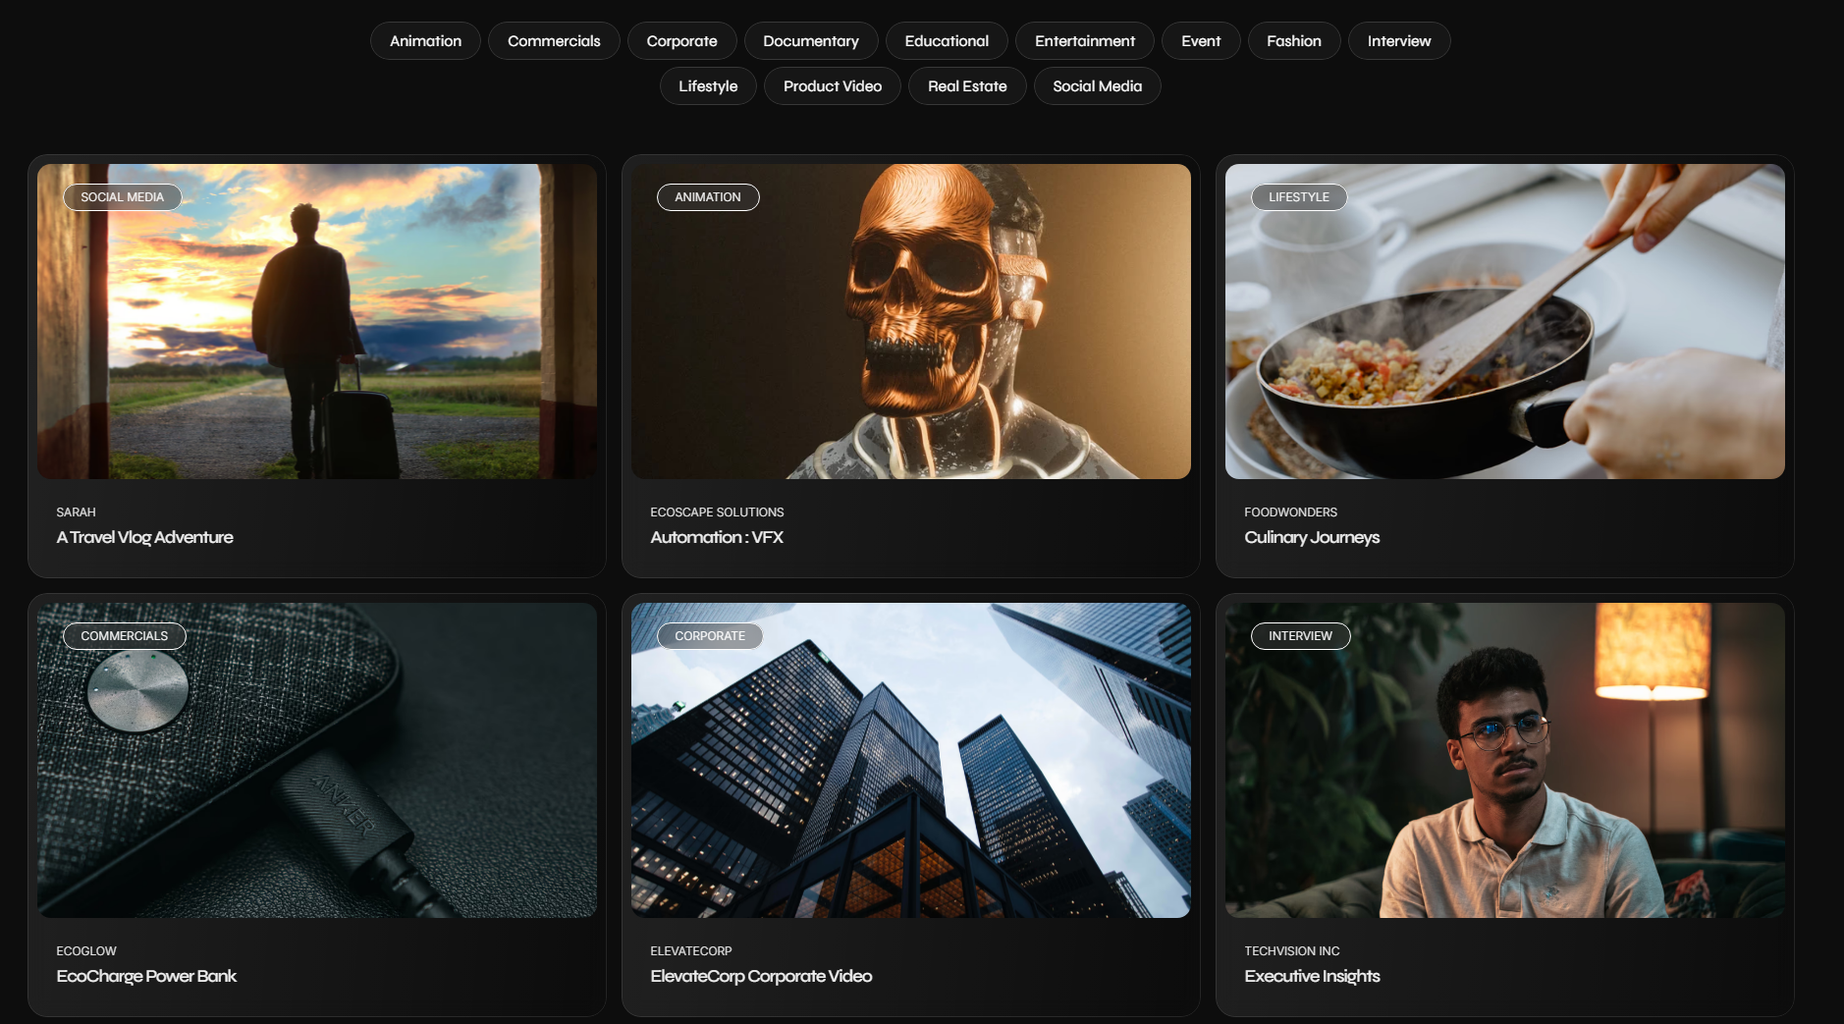

In this image above, there is a thumbnail of the video, a title that tells somebody the name of the project, and a smaller subtitle above it that tells the audience what company or client I worked for to produce it. These titles should be available for everything except the real estate photo album. I should be able to add to this portfolio easily in the future as I complete more client work. The layout in the image above is in a grid-like fashion making it easy to view and select different projects while minimizing scrolling. This makes it easier to navigate and less daunting for the viewer as they might hate all the scrolling.

In addition to the image above, I want a “+” button or something that is somewhere beneath the thumbnail in the same space as the titles and subtitles. When they press the button, it expands the box into the center of the screen. The same information and thumbnail is displayed in this expanded view, but they get to see the play head and timeline of the video as well as a short description of the video alongside the title and subtitle. On top of this, I want a “play button” (in the non-expanded view) that isn’t in the center of the thumbnail but somewhere to the side, like the top right or bottom right corner. This way they can press play in case they want to see the video without needing to expand the box itself. When they expand the box, the video in the smaller box should continue playing in the expanded box view. That is all for this section.

# Services:

Explore Our Services:

* *There should be three categories that the user can pick between. It should look like a slider kind-of unless you have a better idea. When they load the page, “full production” should be the option that’s automatically loaded between the three. When they hover an unselected option, it should show a tooltip of one of these short descriptions. When they select the option, the tool tip description disappears and it reappears somewhere beneath where the three categories are presented*:  
  + **Full Production:** From pre-to-post production, you’ll have the same team or person helping you along the way to ensure a consistent vision across the video project’s development.
    - *Here is what pops up when they select this. There should be an icon attached to each of these options that is animated to make it engaging*:
      * **Commercials:** Cinematic ads that capture attention and drive customer sales.
      * **3D Animation:** Bringing your most complex products and impossible ideas to life.
      * **Social Media:** Creating engaging, scroll-stopping content that builds your online brand.
      * **Real Estate:** Selling properties faster with stunning photos and cinematic video tours.
      * **Corporate Videos:** Professional videos for marketing, training, and building brand trust.
  + **Filming:** Our production-only services supply the people and gear you need to deliver stunning footage directly to your in-house editors:
    - **Cinematography & Lighting:** Expert camera work and lighting for a cinematic, professional look.
    - **Sound Recording:** Capturing crystal-clear, professional audio for your video project.
    - **Drone Videography:** Breathtaking aerial perspectives that give your project an epic scale.
    - **Green Screen Setup:** Transport your subject anywhere with our professional green screen setups.
  + **Editing & Animation:** Have your own footage? Our expert editor or post-production team will craft it into a polished and compelling final video.
    - **Editing:** Assembling your raw footage into a powerful and engaging story.
    - **Sound Mixing and Audio Enhancement:** Balancing audio for a clean, immersive, and professional soundscape.
    - **Colour Grading:** Crafting the mood and tone with a cinematic color style.
    - **2D Motion Graphics:** Adding dynamic animated graphics to enhance your video's message.
    - **3D Animation:** Adding 3D elements to add beautiful visual clarity to your video project
    - **VFX:** Elevating your video with stunning, impossible-to-film visual effects.

*beneath each individual service, there should be a “request” or a “contact” button that takes them to the contact page.*

# Our Process:

**Wanna see how Feel The Frame works?**

*For this page, it’s entirely up to you what design and functionality you come up with. I don’t have any particular text I want or any particular layout. Just make it consistent with the style that I’ve asked from you in previous pages but also do something special that makes this page unique to the other.

What I need for this page is a system that allows me to easily link my youtube videos so that clients see my content and can get an idea of how Feel The Frame works. To be clear, I don’t want people to be redirected to youtube. They should be able to watch the videos from the site itself with the custom video player UI. Each time I add a youtube video to this site, I need to be able to add a title, thumbnail, and short description. As long as you meet that criteria, design it however you want.*

# Contact Page:

I want a contact form setup:

* Want To Collaborate?
  + Name:
  + Email:
  + Phone Number:
  + Message:
  + There should be a “submit” button once everything is filled out
* My basic contact information should be available in case they want to call or reach me without filling out the form:
  + [contact@feeltheframe.ca](mailto:contact@feeltheframe.ca)
  + (613) 447-0896
  + Working hours: 8:30 a.m. to 6:00 p.m. 7 days a week
  + Location: Barrhaven, Ottawa, Ontario (there should be google map showing the location as well or something)

<https://videohut.framer.website/contact>

The website link above has a good design of something I would like. It’s a little bit simple so perhaps you can build upon this in an interesting way. I’ll leave it up to you.

**Also one more thing, on the contact page, there should be a FAQ section:**

**What Video Services do you offer?**

Just about anything you can think of. We offer a wide range of video production services that span every phase of video production from pre-to-post including scriptwriting, location scouting and management, cinematography, sound recording, editing, 3D Animation, vfx and so much more.

**Can you work with a specific budget?**

Yes, you absolutely can. We can’t promise to achieve your exact vision depending on what your budget is, but we will do everything we can to achieve the best results with what’s given to us.

**How Much Does Video Production Services Cost?**

We offer straightforward packages for real estate and social media services. For more complex projects, we provide custom quotes based on your specific needs. Contact us for a detailed estimate at [contact@feeltheframe.ca](mailto:contact@feeltheframe.ca)

**Do you take on Special Projects?**

Feel The Frame specializes in commercial video production but welcomes other creative projects, including music videos, weddings, and events. Reach out to see how we can help.